

**ADempiere How-To**

*Describing*

**Foreign Currency Payments**

*Produced By:*

***XYZ Company Limited***

*Level 1 616 St Kilda Rd  
Melbourne VIC 3004  
Australia  
phone: +61 3 9510 4788  
email: info@adaxa.com.au*

*Contents*

**1** **Payment of a Single Invoice**

1.1 Introduction

1.2 Invoice

1.2.1 The Invoice Accounting

1.3 Payment

1.3.1 The Payment Accounting

1.4 Payment Allocation

1.4.1 View the Allocation

1.4.2 Payment Allocation Accounting

1.5 Bank Reconciliation

1.5.1 Add the Bank Statement Line for the Payment

1.5.2 Bank Statement Accounting

**2** **Payment of Multiple Invoices**

2.1 Introduction

2.1.1 Payment

2.1.2 Payment Allocation

2.1.3 View the Allocation:

2.1.4 Screenshots from the Multi-Invoice Scenario

2.1.5 The Payment Allocation Window

2.1.6 The Payment Allocation Accounting Entries

**3** **Document Summary Sheet**

3.1 Document Information

3.2 Document Revision Record

3.3 Notes

# **Payment of a Single Invoice**

## **Introduction**

This document explains the process used in Compiere to enter and pay foreign currency Invoices ($USD in this example) from a bank account that is denominated in the system accounting currency ($AUD in this example).

In all of the examples below the following exchange rates are used:

* 1 Aug 2005 $USD1.00 = $AUD1.20
* 31 Aug 2005 $USD1.00 = $AUD1.10

## **Invoice**

Enter an invoice header record in $USD by selecting a purchase price list denominated in $USD. Enter an invoice line for 100.00 and allocate the line to a Charge or Product with zero tax. Complete and post the invoice and the Invoice Header will appear as follows:

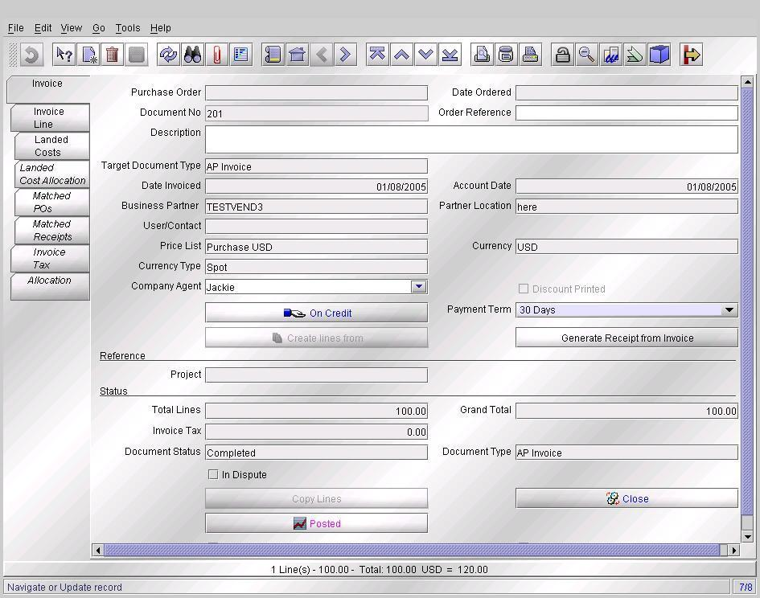

### **The Invoice Accounting**

Accounting entries will be generated as shown below

* Dr Expense or Stock  
  Source Amount = $USD100.00 Accounted Amount = $AUD120.00
* Cr Creditors  
  Source Amount = $USD100.00 Accounted Amount = $AUD120.00

These entries can be seen by clicking the Posted Button on the Invoice Header and are shown below.

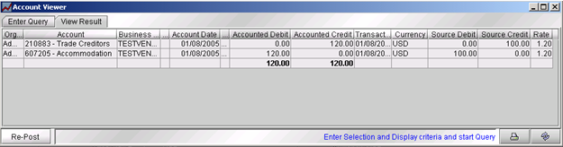

## **Payment**

Assume the invoice is paid by telegraphic transfer on 31 Aug 2005 for $AUD110.00 and incurs an additional $AUD30.00 of bank charges.

* Select the invoice from dropdown list which will show the Payment as $USD100.00
* Complete and Post the Payment

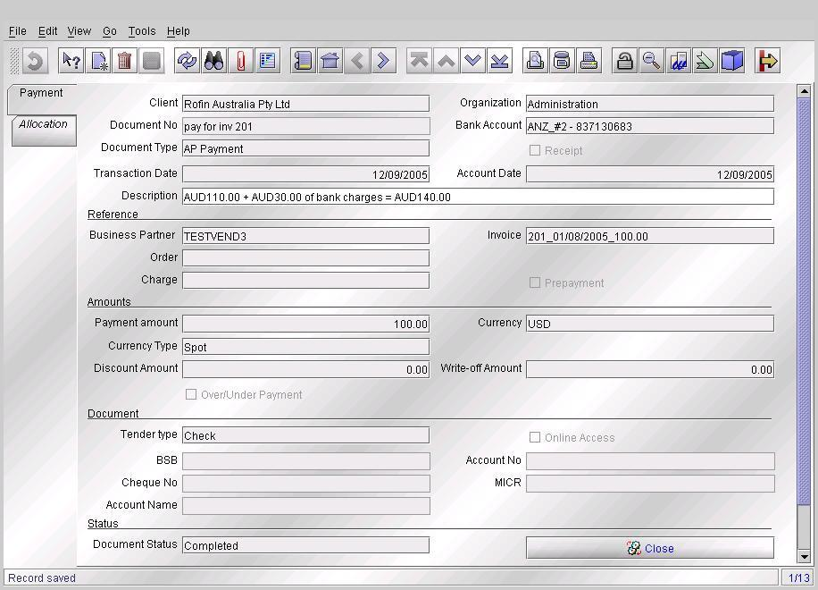

### **The Payment Accounting**

Accounting entries will be generated as follows:

* Debit Payment Selection  
  Source Amount = $USD100.00 Accounted Amount = $AUD110.00
* Credit Bank in Transit  
  Source Amount = $USD100.00 Accounted Amount = $AUD110.00

The extra expense of the Bank Charges will be picked up when entering the Bank Statement reconciliation information at the time of reconciling the bank account. To display the window below, click on the Posted Button on the Payment window.

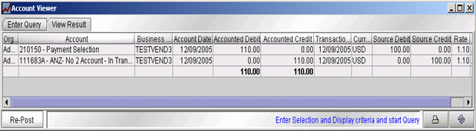

After having posted the payment, note down the $AUD amount that has been calculated by Compiere as shown in the window above. In this example the $AUD amount to be noted is $AUD110.00.

On the Payment window, write in the "Payment Description" field “$AUD110.00 + $AUD30.00 of bank charges = $AUD140.00".

## **Payment Allocation**

Because we are dealing with payment of a single invoice, the allocation has been created by Compiere as a result of selecting the invoice from the drop-down box in the Payment entry. The handling of a payment for multiple invoices is explored at the end of this document.

### **View the Allocation**

Open the View Allocation window; find the appropriate allocation you wish to view. Click on the Posted button if you wish to see the accounting entries generated.

***Hint****: An easy way to find the Allocation is as follows:*

* *open the Payment or Invoice record,*
* *Click on the allocation tab and display in form view.*
* *Right click on the allocation number and zoom to the Allocation record.*

### **Payment Allocation Accounting**

A Payment Allocation Record will be generated with the following accounting entries:

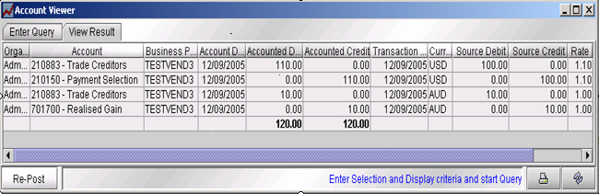

The Allocation will impact the following accounts:

* Debit Trade Creditors by the amount of the Payment of $USD100.00 converted to $AUD110.00 using the exchange rate at the time of the payment
* Credit Payment Selection to clear the credit created when the Payment was entered
* Calculate the exchange gain or loss

In this case the invoice was converted as $AUD120.00 so there was a $AUD120.00 credit to Trade Creditors. The Payment was converted as $AUD110.00 and debited to Trade Creditors therefore a further $AUD10.00 debit is required to clear the $AUD120 credit from the invoice. This is an exchange gain.

The entries generated are:

* Debit Trade Creditors $AUD10.00
* Credit Realised Exchange Gain $AUD10.00

## **Bank Reconciliation**

Create a Bank Statement Header record from the Bank Statement item in the Menu.

The screenshot below already displays a value in the “statement difference” field. A newly created record does not.

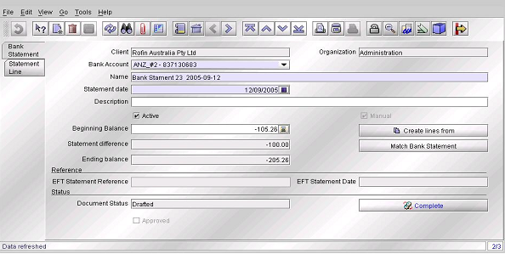

### **Add the Bank Statement Line for the Payment**

Click on the “Create Items From” button and select the Payment (and any other payments that appear on this statement from the bank).

Select the Statement Line tab and select the line that we created above and display it in Form View. The screen will look as shown in the screen shot below.

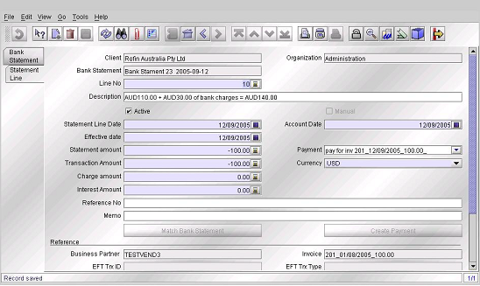

The transaction is displayed in $USD however we need to clear it as an $AUD transaction since this is an $AUD bank account.

Change the Currency to $AUD in the ‘Currency’ dropdown box.

In the description, which has been carried forward from the time we entered the Payment, we can see that the actual debit to our bank was $AUD110.00 plus $AUD30.00 of bank charges.

* Change the Statement Amount to -ve$AUD140.00 (the amount taken out of the Bank Account)
* Change the Transaction Amount -ve$AUD110.00 (being the $AUD amount of the $USD100.00 payment)
* Change the Charge amount -ve$AUD30.00 (being the bank charge) and select the Charge that you want the Bank Fee debited to.

The Bank Statement Line record is shown in the screen shot below.

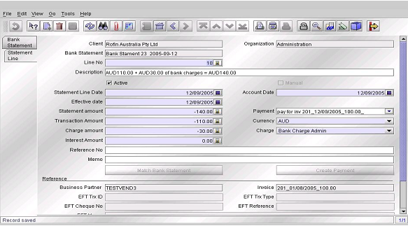

Save the record and return to the Bank Statement tab. This window will now display as follows:

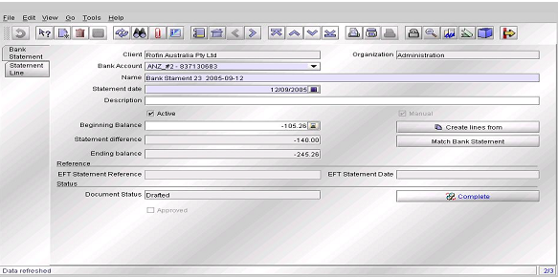

* The Opening Balance of the statement as -ve$AUD105.26
* The movement in the bank position from the items reconciled in this Bank Statement. (In this screenshot, the only transaction is our $AUD 140.00 payment which included the $AUD30.00 of Bank Charges).
* The Ending Balance displayed should be equal to the ending balance on the bank statement you are reconciling to.
* If this is correct complete and post the Bank Statement

IMPORTANT NOTE WHEN ENTERING BANK STATEMENT LINE

***The Payment record was entered in $USD and was converted into $AUD as $AUD110.00. The accounting for that entry was:***

* ***Debit Payment Selection***
* ***Credit Bank in Transit***

***When you take up the payment allocation details in the Bank Statement Line you must enter the exact $AUD amount in the field called “Transaction Amount” which the system converted the $USD payment amount to. This is why we suggest that you record this information in the Payment Description field when creating the payment.***

***The difference (if any) must be allocated to a Charge, probably Bank Fees.***

### **Bank Statement Accounting**

The accounting transactions that result from posting the Bank Statement are shown in the screen shot below:

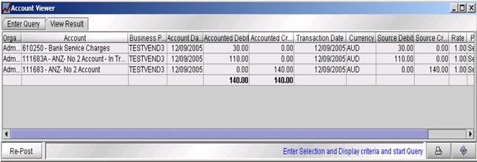

This shows the Bank has been credited by AUD$140.00, Bank Charges have been debited AUD$30.00 and Bank-in-Transit has been debited $AUD110.00 to clear the initial Payment.

Note that the system has generated a debit to the Bank-In-Transit account (111683A) of $AUD110.00. This is the same amount that was credited to this account from the processing of the Payment. The system does not check that you have entered the correct amount and if you enter an incorrect amount the Bank-In-Transit account will not clear to zero. Please refer to the previous comment headed “important note”.

*[As at 24 August 2007 the following bug existed in Compiere Bank Statements.*

<http://sourceforge.net/tracker/index.php?func=detail&aid=1718381&group_id=29057&atid=410215>*.*

*Correction by Journal is the only solution until a fix is made available].*

# **Payment of Multiple Invoices**

## **Introduction**

All invoices paid with a single payment MUST be in the same currency. If a single payment is paying some $USD invoices and some $AUD invoices then the best option is to split the Payment into two Payments, one paying the $USD invoices (which must be entered in $USD) and one paying the $AUD invoices (which must be entered in $AUD).

The process is similar to that for the payment of a single invoice as detailed above with the following exception.

Assume we have three $USD invoices for $USD100.00 each. Also assume that they were entered at different times and with different exchange rates between $USD and $AUD.

* Invoice Number 101a $USD100.00 converted to $AUD129.33
* Invoice Number 101b $USD100.00 converted to $AUD120.00
* Invoice Number 101c $USD100.00 converted to $AUD110.00

<<<< the above needs checking – think it is now wrong >>>>

### **Payment**

The Payment is entered as $USD300.00 and the exchange rate at the time of payment is $USD1.00 equals $AUD1.10.

After Posting the Payment, click on the Posted button and the accounting entries will show the source currency to be $USD300.00 converted to the accounted currency of $AUD330.00.

If you know that the amount that will appear on the bank statement is $AUD360.00 then enters a note in the Payment Description field such as:

“$USD300.00 = $AUD330.00+$AUD30.00 fees” [Note that the $AUD330.00 is the figure which the System has converted the $USD300.00 to]

This will appear as a description on the bank statement line item to prompt you with the exact amount to enter in the required fields in the Bank Statement line.

### **Payment Allocation**

Open the Payment Allocation window from the Menu and complete as follows:

* select the Business Partner
* select the Currency = $USD

The unallocated invoices and payments will be displayed in the window

* identify the Payment to be allocated
* SET THE ALLOCATION DATE EQUAL TO THE PAYMENT DATE

The allocation transaction uses the currency exchange rate applicable at the date specified for the allocation transaction. If the exchange rate is different to the exchange rate applicable at the date of the payment then a difference will be generated in the Payment Selection Account which will have to be manually journalled to the realised exchange gain/loss account at a later time. This is avoided when the allocation date and payment dates are the same since they then occur at the same currency exchange rate.

Tick the Payment and the related Invoices so that the applied total in the Payment section is equal to the applied total in the invoice area. If one or more invoices are being part-paid then set the applied amount accordingly. The allocation can then be processed by pressing the process button.

### **View the Allocation:**

Open the View Allocation window, find the appropriate allocation. Click on the Posted button to see the accounting entries generated by the system.

Hint: An easy way to find the Allocation is:

* open the Payment or Invoice record,
* click on the allocation tab and display in form view.
* Right click on the allocation number and zoom to the Allocation record.

**The process after this is the same as for a single invoice payment.**

### **Screenshots from the Multi-Invoice Scenario**

Shown below are screenshots from the multi-invoice scenario that are different from the single invoice scenario.

### **The Payment Allocation Window**

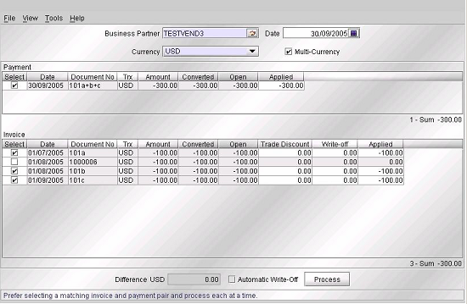

### **The Payment Allocation Accounting Entries**

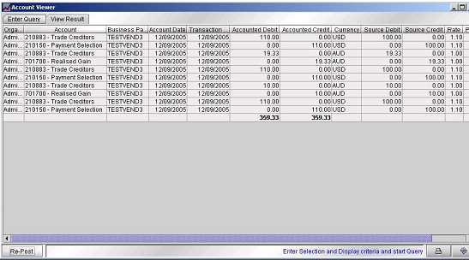

# **Document Summary Sheet**

## **Document Information**

|  |
| --- |
| **Title:**  Foreign Currency Payments |
| **Type of Document:**  **ADempiere How-To** |
| **Summary:** *(Brief description of document)*  hgdhggskljs |
| **Work Carried Out By: (Team initials or names)**  hgdhggskljs | **Reference:**  hgdhggskljs |

## **Document Revision Record**

|  |  |  |  |
| --- | --- | --- | --- |
| **File Name** | **Rev No.** | **Issue Date** | **Reason for Issue** |
| AD_howto_foreign_currency_payments v2.doc | 1.00 |  | hgdhggskljs |

## **Notes**

This document was prepared for the purposes set out herein. Responsibility is disclaimed for any loss or damage (including but not limited to damage resulting from the use by the reader of the document) suffered by any other person for any reason at all including but not limited to negligence of any person. Whilst this document is accurate to the best of our knowledge and belief, the author can not and does not guarantee the completeness or accuracy of information contained herein.

This document is copyright to: ADAXA Pty Ltd

Permission is granted to copy, reproduce and publish this document provide it is reproduced it its entirety including all authorship and copyright notices.